Lab 7 Week 9 11.03.26

Given:
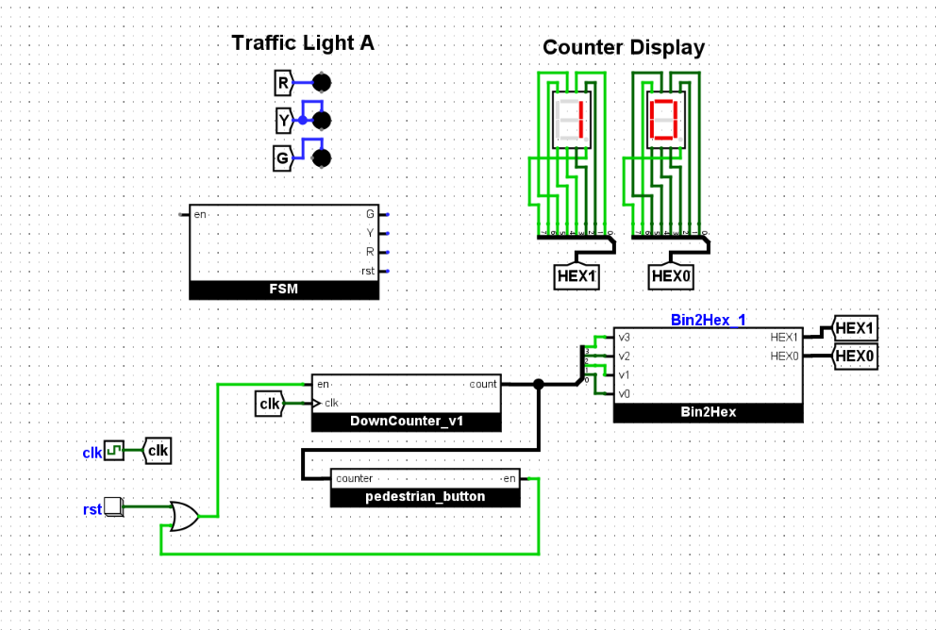
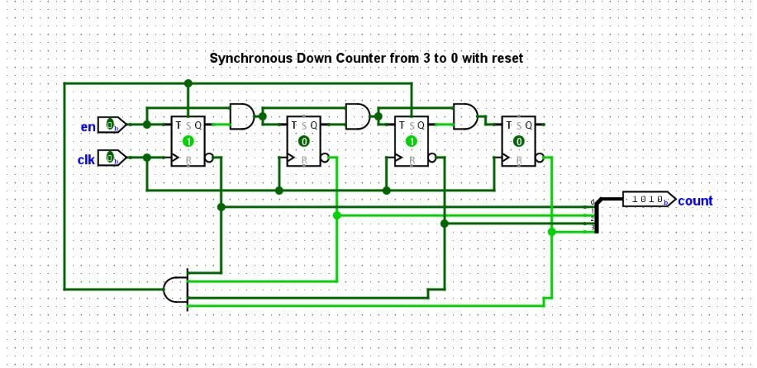

Asked:
1. Fix “DownCounter_v1” to count from 3 to 0
2. Design the FSM to cycle between Green, Yellow, Red traffic lights
3. Implement the FSM in Logisim
4. Connect the FSM to the rest of the circuit

Step 1:
We were given a down counter that went from 10-0. It worked by setting the pins to represent 10’s complement every time the counter reached 0. To make this work for 3, I changed the pins to set 3’s complement. And cycle from 3,2,1,0,3…
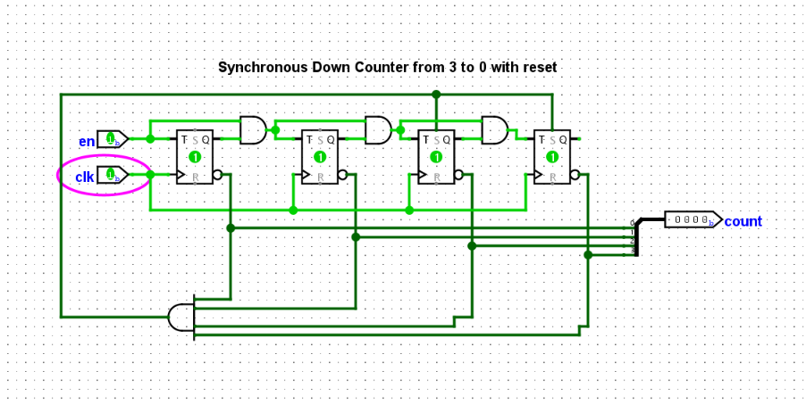
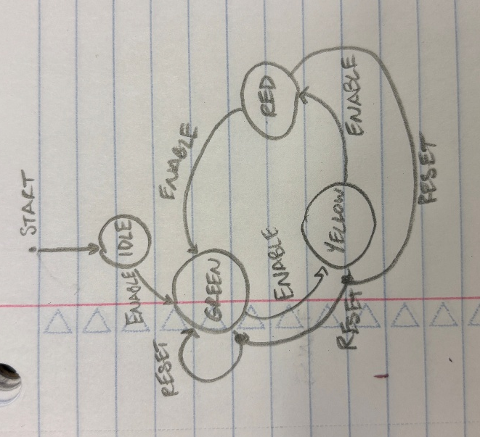
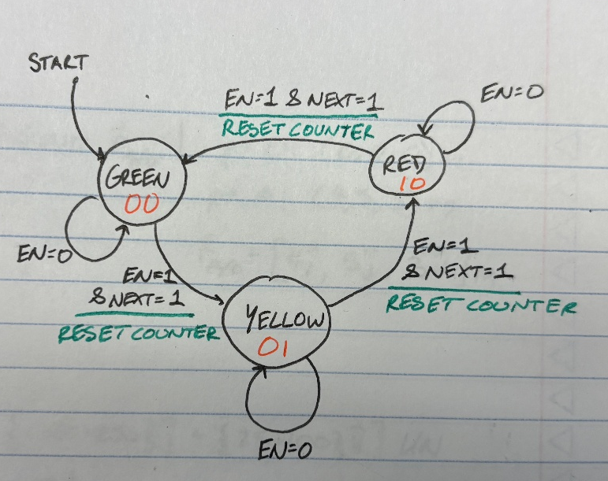
Step 2:

On the left is my original design, and the right is what we ended up using for building. My original only used enables high state, and not the low to signal staying within the same output. And reset was used to always represent a green output but that was not desired. The ‘next’ input is to represent the counter state. The inputs also need 2 outputs. Switching colors and resetting the timer.
Step 3:
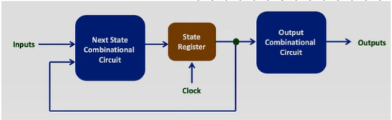
Create designs based off these charts

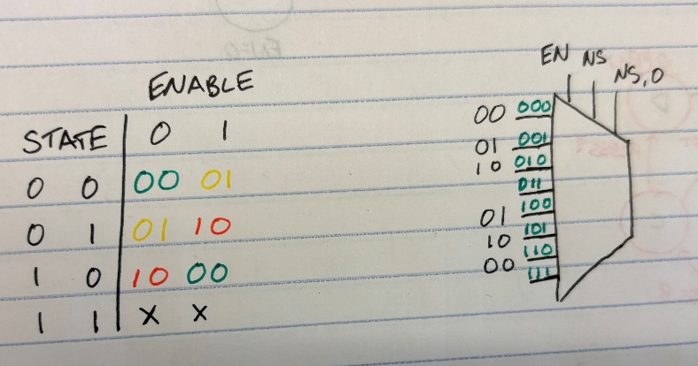
When enable= 0 we want to keep current state. Or when New_State= 0 we want to keep current state.
When enabled and newstate=1, shift to next color

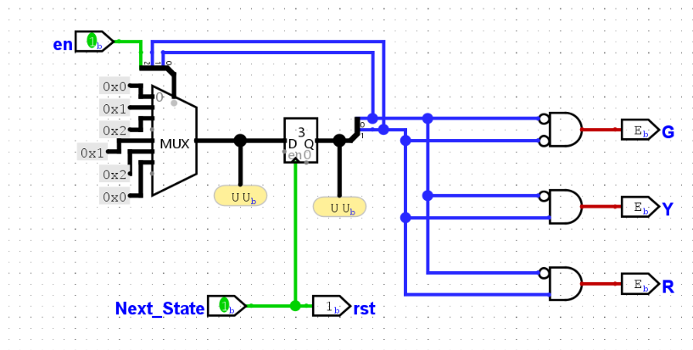

When next state is high it resets the counter; enable plus previous outputs select pins.
Green is represented by 00; Yellow 01; and Red 10; as shown in truth table. And gates are used to output high under these conditions and connect to respective colors.

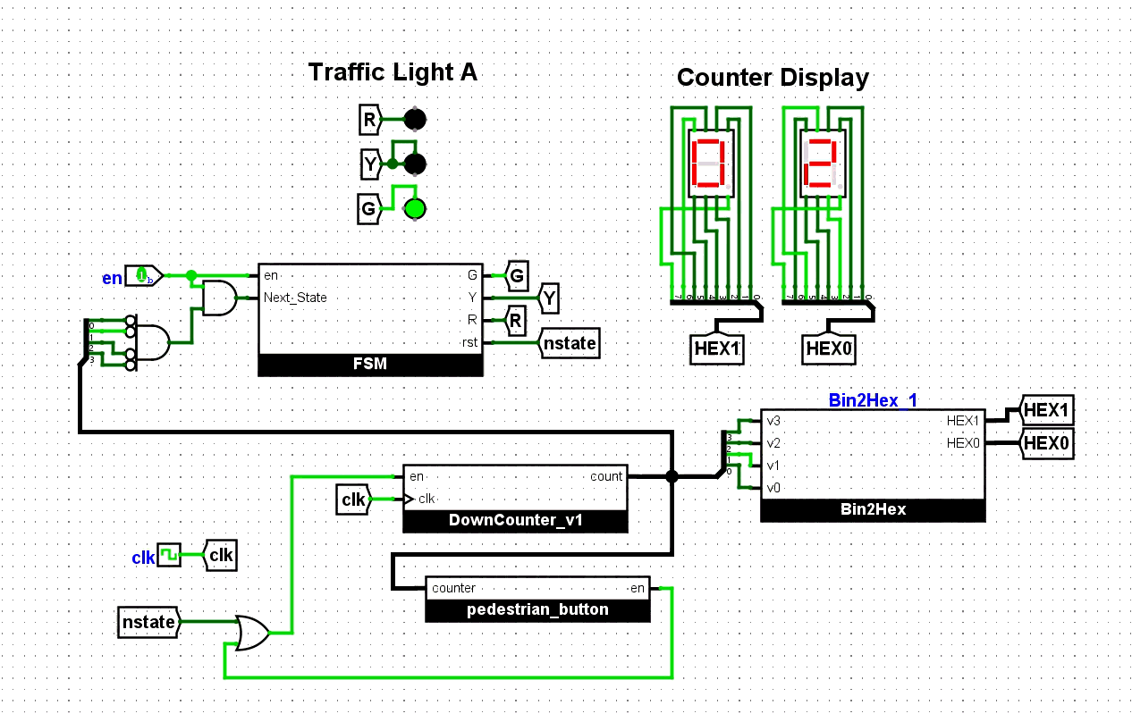
Final Design

